CRAPE MYRTLES:
FOUR SEASONS OF BEAUTY
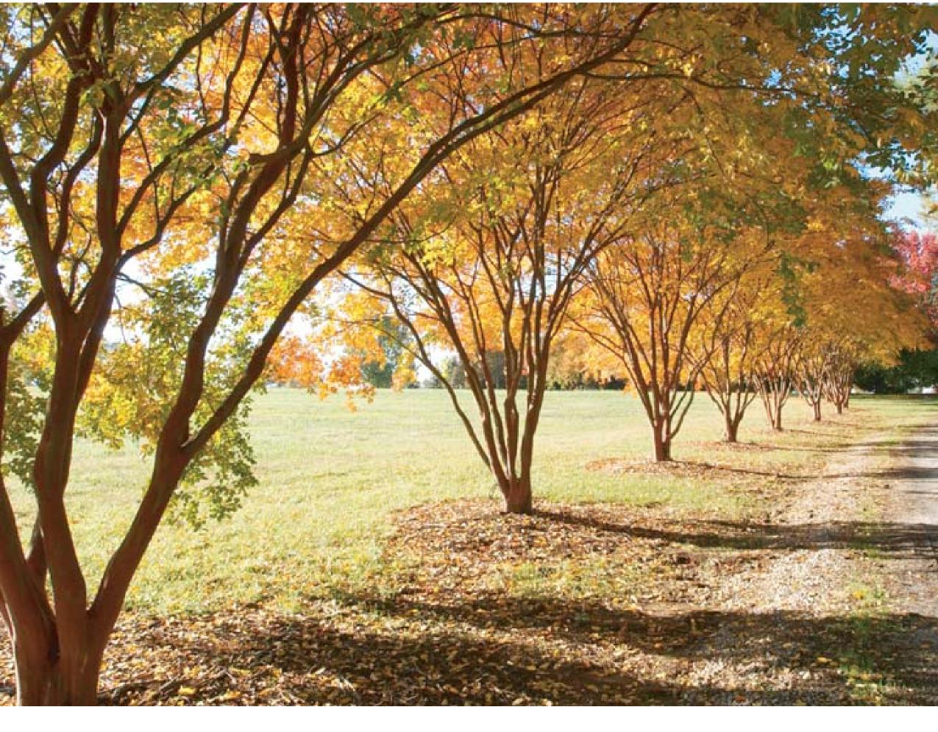

CRAPE MYRTLE SELECTION
First select the right size and shape of crape myrtle for your location. Plan for the tree’s full size at maturity, rather than relying on severe pruning to keep it within bounds. This will ensure a graceful silhouette all year round. Select named and labeled varieties from a reliable nursery to be certain of the plant’s final size and to ensure healthy stock.
Characteristics of Crape Myrtle Varieties

NAME OF | APPROX. | GROWTH HABIT | FLOWER COLOR | MILDEW | FALL LEAF | EXFOLIATING
 | HEIGHT IN FEET
CULTIVAR | AT MATURITY |  |  | RESISTANCE | COLOR | BARK
Centennial | 2 - 3 | Dwarf, round shrub | Bright Purple | Good | Orange | No, Smooth
Chickasaw | 2 - 3 | Miniature | Pink - Lavender | High | N / A | N / A
Pocomoke | 2 - 3 | Miniature Weeping | Red | Good | N / A | N / A
Tightwad Red | 2 - 4 | Dwarf | Light Red | High | N / A | N / A
Velma's Royal Delight | 2 - 4 | Compact | Purple | Good | Yellow orange | Average
Victor | 3 - 5 | Upright Dwarf | Deep Red | Good | Yellow | No, Smooth
Acoma | 6 - 10 | Low, spreading,  arching | White | High | Purple red | Great
Hopi | 8 - 10 | Low, spreading | Medium Pink | High | Orange red | Great
Pecos | 8 - 10 | Low globose | Medium Pink | High | Maroon | Good
Prairie Lace | 8 - 10 | Upright, semi  dwarf shrub | Medium Pink  edged in White | Fair | Red to Red  Orange | No, Smooth
Centennial Spirit | 8 - 12 | Upright | Dark Red | Good | Red orange | Average
Tonto | 8 - 12 | Compact globose | Red | High | Bright maroon | Good
Zuni | 9 - 12 | Globose | Medium Lavender | High | Red orange | Good
Regal Red | 10 - 12 | Upright, rounded  tree to 12’ wide | Deep Red | Good | Red orange | No, Smooth
Yvonne | 10 - 15 | Compact globose | Pink - Lavender | Good | N / A | N / A
Catawba | 12 - 15 | Upright | Violet Purple | Good | Red orange | Average
Conestoga | 12 - 15 | Open arching | Pale Lavender | Good | Yellow | Average
Sioux | 12 - 15 | Upright | Vibrant Pink | High | Maroon | Good
William Toovey, aka Watermelon Red | 12 - 15 | Vase-shaped small  tree | Watermelon Red | Good | Red orange | No, Smooth
Byers Wonderful White | 15 - 20 | Upright small tree | White | Good | Yellow | No, Smooth
Choctaw | 15 - 20 | Small tree | Bright Pink | High | Maroon | Great
Comanche | 15 - 20 | Broad crown | Coral Pink | High | Orange red | Great
Lipan | 15 - 20 | Broad upright | Medium Lavender | High | Orange | Best
Near East | 15 - 20 | Open spreading | Light Pink | Moderate | Yellow orange | Average
Osage | 15 - 20 | Arching, open | Clear Pink | High | Red | Great
Potomac | 15 - 20 | Upright Small Tree | Clear Pink | High | Orange | No, Smooth
Raspberry Sundae | 15 - 20 | Upright | Cardinal red to  pink | Good | Orange red | Average
Seminole | 15 - 20 | Compact globose | Medium Pink | Good | Yellow | Average
Yuma | 15 - 20 | Broad upright | Medium Lavender | Good | Yellow orange | Good
Tuskegee | 15 - 25 | Broad spreading | Dark Pink | High | Red orange | Great
Dynamite | 20 - 25 | Upright | Red | Good | N / A | Average
Tuscarora | 20 -25 | Broad vase | Dark Pink | High | Red orange | Great

Characteristics of Crape Myrtle Varieties, Cont.

NAME OF | APPROX. | GROWTH HABIT | FLOWER COLOR | MILDEW | FALL LEAF | EXFOLIATING
 | HEIGHT IN FEET
CULTIVAR | AT MATURITY |  |  | RESISTANCE | COLOR | BARK
Natchez | 20 - 30 | Broad tall tree | White | High | Red orange | Great
Carolina Beauty | 20+ | Very upright | Park Red | Poor | Orange | Average
Dallas Red | 20 + | Broad upright | Red | High | N / A | N / A
Miami | 20 + | Upright | Dark Pink | High | Orange | Great
Red Rocket | 20 + | Upright | Cherry Red | High | N / A | Average
Basham's Party Pink | 25 + | Broad tall tree | Light Lavender | Good | Orange red | Good
Muskogee | 25 + | Broad tall tree | Light Lavender | High | Red / Orange | Good
Biloxi | 30 + | Upright vase | Pale Pink | High | Orange red | Great

List compiled from Southern Living Garden Book; Fanick’s Garden Center in San Antonio, TX; University of Georgia web-site; Auburn University website.
CARE OF CRAPE MYRTLES
Crape myrtles are one of the Southeast’s most beautiful small trees and were introduced into the United States in 1747 from China, Korea, and later on from Japan.
Their excellent drought resistance, fast growth, beautiful flowers, and low maintenance requirements make them very popular. Many cultivars have superb bark interest and great fall leaf color as well. About their only drawbacks are a tendency to grow suckers at the base that need removing on tree-shaped cultivars, and a tendency for some cultivars to be susceptible to mildew.
LOCATION: They are hardy in Zones 7-9, and ideal for Spartanburg. Crape myrtles prefer a hot climate and need full sun to bloom. Select a southern or western exposure whenever possible, for best flowering and to reduce problems with powdery mildew.
PLANTING: Able to survive in almost any type of soil, crape myrtles do best in well-drained locations. For clay soils mix in pea gravel or very finely ground pine bark to improve drainage. Place the tree into a hole dug twice as wide as the root ball, with the top of the root collar (the part where the trunk flares out into the root system) level with, or 1-2” above, ground level. Best times to plant are Fall and early Spring, with Fall being preferred, as the roots will continue to grow during the warmer parts of the dormant seasons.
WATERING: For the first season, a newly planted tree from a 5 gallon container needs 10 gallons of water per week, if there is no rain, and preferrably delivered in 2 applications of 5 gallons each. Larger transplants would need more. Water as needed during droughts. Crape myrtles are very drought resistant once established.
FERTILIZING: Apply a slow release fertilizer with a 3-1-1 ratio of nitrogen to phosphorous and potassium. Examples include a 12-4-4 or 18-6-6 fertilizer, applied in late Winter or early Spring as leaves emerge, and again in July. For a 6-10’ tall crape myrtle, 2-3 cups of an 18-6-6 should be applied uniformly beneath the canopy. For a 15-25’ tall tree, 1-2 quarts of fertilizer should be used. Do not fertilize after Labor Day. Note that excessive nitrogen (runoff from turf fertilizers) can delay flowering and reduce cold hardiness. (ANSI A-300 and International Society of Arboriculture.)
MULCHING: A 2-4” deep (maximum) layer of pine bark or hardwood mulch or pine needles around the tree base, spread all the way out to the edge of the tree canopy (the dripline), helps control weeds and conserve moisture. Leave a 4” open space on all sides of the trunks, to avoid stressing stem tissues. Avoid 8-10” tall mulch “volcanoes”, which can provide housing for rodents, cause root rot, and cause adventitious roots (out-of-place roots that grow into the mulch rather than into the ground).

PRUNING OF CRAPE MYRTLES
“DO’S”
The thoughtful gardener or landscaper strives to provide welcoming beauty and architectural elegance year-round in outdoor living spaces, and proper pruning techniques help achieve these goals.
For crape myrtles, pruning should be minimal, to remove basal suckers and damaged or crossed limbs. The natural round shrub or tree-form shape provides the best silhouette all year, promotes the healthiest growth of the plant, and costs the least amount of time and money to maintain.
- DO prune when the tree is dormant, just before bud break, in the late Winter or early Spring, but only if the sap is not frozen. Best time to prune is January through April. Pruning between August and December has been shown to significantly reduce the cold hardiness of crape myrtles, increasing the risk of killing the tree during winter. (C. Haynes, PhD., 1991 Hort Science 26:1381-1383).
- DO remove broken, dead and crossed limbs. Remove suckers at the base of the tree and at the trunk.
- DO limb up the tree, by pruning off the side branches, if a tree form is desired, instead of a rounded shrubby shape. Try to do this before limbs get bigger around than a pencil, to avoid leaving a scar. Small cuts do less damage to the tree than large cuts, and heal more quickly as well.
- DO limit pruning to no more than 25% of the live branches in a single year. If necessary, prune neglected plants over a period of years to obtain the desired appearance.
- DO know that excessive pruning does not induce heavier flowering, but rather reduces it, due to the removal of significant plant carbon and nutrient reserves. (Texas A&M University, http://dallas.tamu.edu/woody/cmyrtle/ pruning.html) Do encourage repeat flowering (if desired, and if you can reach!) on cultivars that bloom in May/June, by removing seed heads just as they are forming. Leave the late summer seed heads from all varieties to fall naturally, as pruning these in late Summer or Fall reduces cold hardiness.
- DO refrain from pruning if in doubt. Under-pruning is easy to correct; over-pruning causes permanent damage.
TREE FORM: Beautiful year-round architectural silhouettes
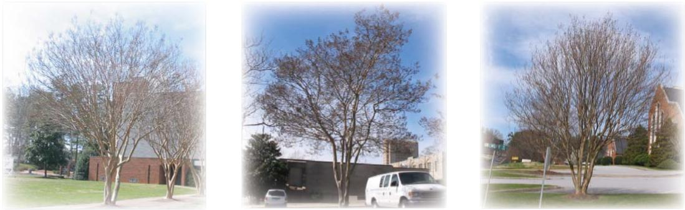

PRUNING OF CRAPE MYRTLES
“DONT’s”
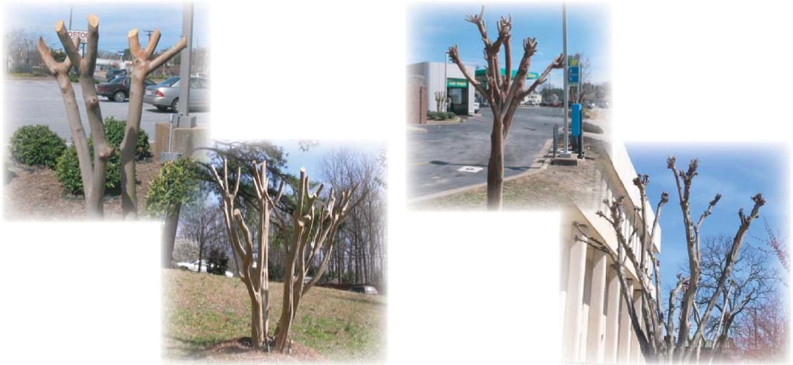
Topping or Pollarding
Hat Racking
“Don’t pay your landscaper to devalue your property.” -Kevin Parris, Parris Landscape Design
- DON’T “top” the tree or “round over” the shrub by sawing off all the branches except the main trunks. Topping is perhaps the most harmful pruning practice known, according to the International Society of Arboriculture. Topping can cause immediate dieback and/or the growth of a “broom” or “pom pom”, which are long thin shoots that are grown from just under the bark. These are poorly attached and easily broken off, and a very dense “broom” can cause the tree to topple in high winds. Additionally, topping lowers the life expectancy of a tree by at least one-third and destroys
its beauty. (Pruning Techniques, 1991, Brooklyn Botanic Garden Record, p.15 and “Why Topping Hurts Trees”, Int’l Society of Arboriculture’s website - http://www.treesaregood.com/treecare/topping.asp)
- DON’T “pollard” the crape myrtle. This pruning method, along with “topping”, is called “Crape Murder” by Steve Bender, Southern Living magazine’s senior garden writer. Pollarding involves cutting off all the previous year’s branches to a “knuckle” or “knob” at or close to the main trunks. This type of pruning produces similar stresses to that of “topping”, including a shorter life span and an ugly tree silhouette before leaf-out. Some Southern cities, such as Charlotte, NC, have ordinances against this type of pruning because it costs extra money for “unnecessary” pruning, it makes the tree unattractive while dormant, and it costs money to replace the trees more frequently. It is better to purchase appropriately-sized cultivars to begin with or to relocate a tree if it gets too large for the site. (Crape myrtles are very resilient and tough, and are fairly easy to move.)
RENOVATING A POORLY PRUNED CRAPE MYRTLE:
- Let a “murdered” tree with large diameter trunks (1" caliper or more) grow out for a season, and in early the following Spring, select one, two or possibly three dominant branches per trunk to grow out over time. Prune off smaller side branches, taking out no more than 25% of the live branches in a single year. You may need to prune side branches over several years to allow the tree form to develop and to allow evidence of the big cuts to grow over.
- Smaller-trunked trees that need corrective pruning can be cut flush with the ground in early Spring, and an odd number of trunks (3, 5 or 7) allowed to regrow in the natural tree form.
“CRAPE MURDER”: 6 Months of Ugly

Resources used to develop this brochure include:
The American Horticultural Society Encyclopedia of Garden Plants, Christopher Brickell, editor. ©1989, revised 1992.
Auburn University, http://www.ag.auburn.edu/dept/hf/landscape/crapemyrtle2.htm
Clemson University, http://hgig.clemson.edu
Bruce Fraedrich, PHD, Bartlett Tree Research Labs
International Society of Arboriculture, www.treesaregood.com, consumer website.
Manual of Woody Landscape Plants, Michael A. Dirr, ©1975, revised 1998.
Month-By-Month Gardening in the South, Don Hastings and Chris Hastings, ©1996.
Pruning Techniques, Brooklyn Botanic Garden Record, ©1991.
Pruning Trees, Shrubs & Vines, Brooklyn Botanic Garden Record, ©2003.
South Carolina’s Garden Guide, Jim Wilson, ©1997.
The Southern Living Garden Book, Steve Bender, editor, 1998.
Texas A&M University, http:dallas.tamu.edu/woody/cmyrtle
Thomas Jefferson’s Garden Book, annotated by Edwin Morris Betts, ©1944, reprinted 1981.
Time-Tested Plants: Thirty Years in a Four Season Garden, Pamela J. Harper, ©2000.
University of Georgia, http://www.ces.uga.edu/pubcd/L331.htm

Spartanburg Men’s Garden Club 521 Mockingbird Lane Spartanburg, SC 29307 | Non-Profi t Org.  U.S. Postage  PAID  Permit 155  Spartanburg, SC

©2004 Spartanburg Men’s Garden Club. Brochure researched and designed by Lyn Murajda and Henry Pittman.
Page layout courtesy of Monica Allen. Printed courtesy of Keys Printing.

